***Totalitarian Dice***

## 

***Amit van Dijk***

***Nati Tsimerman***

***V 0.5***

***13/02/18***

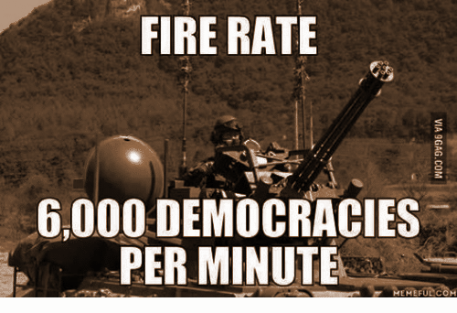 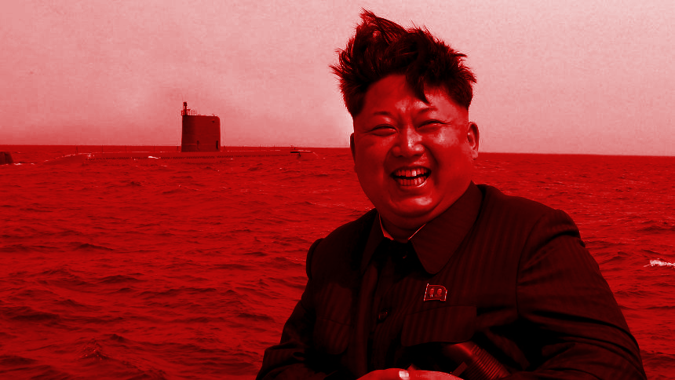

## 

# INDEX

**INDEX** **1**

**Change Log** **2**

**1. General description** **2**

1.1 Genre 2

1.2 Narrative 3

1.3 Inspiration 3

1.4 Concept 3

1.5 Technical Info And Requirements 3

**2. Gameplay** **4**

2.1 General Gameplay 4

2.2 Turn Sequence 4

2.3 Game Modes 5

2.4 Winning/ losing conditions 5

2.5 Tutorial 6

**3. Mechanics** **6**

3.1 Matchmaking 6

3.2 Actions 6

3.3 Power Ups 7

3.4 World Map 7

3.5 Victory Points 8

**4. Look & Feel** **8**

4.1 General Look 8

4.2 Art style 9

4.3 Sounds 9

**5. Asset List** **9**

5.1 Graphical assets 9

5.2 Sound Assets 12

**6. UI** **13**

6.1 Menus 13

Main Menu 14

Options Menu 14

Credits 14

6.2 In-game 14

7.3 Flowchart 15

6.4 Wireframes 16

# Change Log

|  |  |  |
| --- | --- | --- |
| Version | Date | Main Changes |
| 0.1 | 05/02/18 | Formed general structure of the document and began some early work on General Descriptions, Gameplay |
| 0.2 | 07/02/18 | Worked on asset lists and more in-depth descriptions for mechanics, gameplay, scoring, and look & feel |
| 0.3 | 09/02/18 | Worked more on mechanics and asset lists, added more headings and sub-headings, various minor edits |
| 0.4 | 11/02/18 | Added more headings and information, a tutorial, UI explanations, revised same game rules and mechanics |
| 0.5 | 13/02/18 | Added final touches, wireframes, flowchart, more explanations for the mechanics and aesthetics, proofread |

# 1. General description

## 1.1 Genre

The game is a turn-based, strategy, dice game intended for the mobile platform.

It is a multiplayer game with the option to play against AI instead of other players.

Matches are intended to be relatively quick (around 5-10 minutes), and will be played from a top-down view.

## 1.2 Narrative

Leaders around the world started to feel their grip on power faltering. They decided that the best way to hold on to their seats of power was to promote a dictatorship regime in their countries. In the beginning, the newly emerged dictators only solidified their hold on their own countries, but their lust for power only grew stronger. They decided that one country was not enough. They had to spread their own superior culture to the rest of the world, by force, if necessary!

## 1.3 Inspiration

We took great inspiration from famous games like “Yahtzee” and “Risk”.

Yahtzee is a dice-based luck game with an interesting mechanic of rerolling dice that the player is unhappy with, in order to try to achieve certain sets of dice that score more points.

Risk is a strategy board game that also contains dice. The board is a map of the world. Players spread troops in different countries and move them around to conquer other countries while defending their own territories.

## 1.4 Concept

The game will have the players take the role of different dictators that will be available in the game. They will need to roll, and often reroll, dice in order to decide where and how strongly they will be attacking and defending each turn. Despite the grim concept, the atmosphere will be humoristic and cartoon-ish to keep things on the lighter side and to open the game to a wider audience.

## 1.5 Technical Info And Requirements

1. The game will be developed on the Unity Engine
2. Android version X.X and above will be required to play
3. Will work in different resolutions in accordance with today’s variety of phones
4. Internet connection is required for multiplayer (non-NPC) functionality
5. Location services required for the game to automatically place players in their own country during the tutorial (where possible)

# 2. Gameplay

## 2.1 General Gameplay

Before a match starts, each player chooses a dictator. This will determine matchmaking[1].

2.1.1 At the start of the game, the players will be presented with a map of the world with **highlighted countries**[2].

2.1.2 They will be situated in countries according to their choice of dictator.

2.1.3 At the start of each of their individual turns, the players will be presented with 6 d24 (24-sided die) dice which they must roll.

2.1.4 After the initial roll, the players can decide whether they want to reroll one or more of their dice or keep the dice from their initial roll.

2.1.5 Only one reroll is allowed, unless the player has the “3rd Reroll Powerup”

2.1.6 At the end of the turn, the players’ final dice will determine what **actions[3]** will be played and on which countries.

## 2.2 Turn Sequence

Each turn will consist of two active phases and will end with a passive phase.

2.2.1 Active Phase

* + The first **Active Phase** is the **Roll Phase.** The player is given 6 dice and their only available action is to roll them.
  + A short animation sequence of dice being rolled will be played and then the player will be shown their 6 dice again with the countries that were rolled.
  + The second active phase is the Reroll Phase. The player will be given the option to pick any of their 6 dice and roll them again to try to improve their results in their attempt to perform certain actions on certain countries. The player may choose to simply skip the reroll phase and keep all their dice.
  + Another roll sequence will be played out with the chosen dice (if any) being rolled again. The dice that were kept will remain static on display.

2.2.2 Passive Phase

* + The final phase is a **Passive Phase**. Once the final result is shown, after the roll and reroll phases, The Action Phase will begin. This is merely a phase to show what the results of the players’ rolls caused. Animations will play out of countries being attacked, various dictators displaying their emotions, etc (Animations and dictator reactions will be discussed later in Look & Feel).

## 2.3 Game Modes

2.3.1 Multiplayer

* The main game mode will be multiplayer mode. Players who have picked different dictators from each other will be joined into a multiplayer match. The match will be filled with AI in place of players if no matches were found[4] The AI will pick random unpicked dictators.
* AI in multiplayer matches will be set to a difficulty that is relevant to the human players’ average **scores[5]**.

2.3.2 Player vs AI

* Will mostly be used for practice. Will not increase or decrease a player’s score. AI will have a difficulty setting that can be changed by the player (Easy, Intermediate, Hard).

## 2.4 Winning / losing conditions

2.4.1 Winning

When a player conquers the whole map (or if all other players have quit) they win the match and will be rewarded with **Victory Points**[6].

2.4.2 Losing

When a player loses all their controlled countries they lose the match, losing a match will decrease player’s Victory Points.

## 2.5 Tutorial

* The tutorial will be a build-up style tutorial that will consist of 4 levels and a single opponent called **Vasily**:

1. The player will enter a match against Vasily. The player will have only 1 die to roll (the die will have only Vasily-land on it) to take over his country and win the match. The player will learn that in order to cause damage to a country, he has to roll dice that will match that country.
2. The player will enter a match against Vasily. In this level, both the player’s country and Vasily-land will have low **health[7]**, the player will have 4 dice to roll, 3 dice will **heal** the player’s country and the other 1 will **damage** Vasily-land, and will destroy it. The player will learn how to heal his countries.
3. The player will enter a match against Vasily, in this tutorial the player’s country has full health and Vasily-land has 1 health point. The player will have to roll 4 dice again. 3 dice will come up with his country’s flag, which will **fortify** his country, and 1 with Vasily-land which will destroy it. The player will learn how to fortify his countries.
4. This tutorial level will be the final match against Vasily. In this tutorial the player will play a full match against Vasily which will consist of 1 country each, in full health and 4 dice containing the countries flags. If the player loses the match, they will be asked if they want to try again.

* The tutorial will be played on the first time a player enters the game.
* The player will have an option in the Options Menu to play the tutorial again.

# 3. Mechanics

## 3.1 Matchmaking

The matchmaking system will determine which players can play against each other; sorting them by Victory Points and the dictator they chose (as mentioned above, a dictator is chosen before entering the matchmaking phase). The game will not match the same dictators against each other and will try to match players that have relatively similar scores. After a set amount of time, if no opponents were found, the game will instead place random AI opponents against the players, that will be set to either Easy, Intermediate, or Hard difficulty according to all human players average scores.

## 3.2 Actions

3.2.1 Attack

* Players can damage countries according to the dice they rolled during their Active Phase. One die equals one damage point.
* If the country the player attacked loses all its health, control over that country will switch to that player (see 3.3 Capturing Territories).

3.2.2 Heal

* Players can heal countries according to the dice they rolled in their Active Phases. One die equals one health point. A player cannot heal a country beyond its max health, but they can **fortify** them.

3.2.3 Fortify

Scoring 3 dice for your own country when it has **full health[8]** will add 1 **shield**[9] point to that country, fortifying it.

## 3.3 Capturing Territories

3.3.1 Occupied Territories

* Both occupied and unoccupied territories start out with 3 health.
* Occupied countries have persistent health, meaning that when damage is caused to them or when they are healed, their current health will persist to the next turns.
* When a player manages to take a country’s health down to zero, that country is captured.
* When a country is captured, its health resets back to 3.

3.3.2 Unoccupied Territories

* As mentioned above, unoccupied countries also start with 3 health.
* Unoccupied countries’ health resets back to 3 at the end of each turn.
* A player must match 3 dice in a single turn in order to capture an unoccupied country.

## 3.4 Power Ups

3.4.1 Controlling certain areas of the map will grant additional powers to the controlling player.

3.4.2 Every 3rd turn is a **Power Up Turn** (turns 3, 6, 9, 12, etc)

3.4.3 If a player is in complete control of certain continents, they will receive one of these power ups:

* 3rd Throw (Acquired by controlling all of Europe)
* Extra Dmg (Acquired by controlling all of Asia)
* Extra Heal (Acquired by controlling all of North America)
* Extra Shield (Acquired by controlling all of Africa)

3.4.4 Russia will be counted with Europe.

3.4.5 Israel will be counted with Africa.

## 3.5 World Map

3.5.1 Map Overview

* The world map will consist of 24 active territories and countries - which will be highlighted[10].
* Some of our eager dictators have already annexed other countries into their fold. The territory list (3.4.2) will explain which areas of the map belong to which countries.
* The countries in between the actives will be greyed out to signify that they are not a part of the game.
* The dice will still have 12 flags on their 24 sides, but each side will also have a line of text to signify which territory it’s referring to.

3.5.2 Territory List

* USA - West USA + East USA
* Canada - West Canada + East Canada
* Israel - Israel + Egypt
* North Korea - North Korea + South Korea
* Iraq - Iraq + Iran
* Libya - Libya + Algeria
* Russia - Russia + Ukraine
* Japan - Japan + China
* Uganda - Uganda + Kenya
* France - France + Spain
* Germany - Germany + Poland
* Italy - Italy + Greece

3.5.3 Territory Colors

* To understand the world map better. Countries will be highlighted or greyed out according to their ownership and interactivity.
* Countries that are not in the game will be greyed out in the map.
* Countries that are active and are controlled by one of the players or AI will be colored in that dictator’s colors (See 5.1 Graphical Assets).
* Countries that are active but unoccupied will be highlighted in white.

## 3.6 Victory Points

* Victory Points will determine the experience of the player and will be used in the matchmaking system.
* Points will increase or decrease according to the player’s match history (see section Winning/ losing conditions).
* Each player will receive Victory Points after each match according to their performance on that match, winning a match will grant the highest amount of points while being the first player to lose will grant the lowest amount.
* Winning will increase player score by 10 points while losing will decrease player score by 10

# 4. Look & Feel

## 4.1 General Look

The game will have a cartoonish look to soften the general idea of war and dictatorship (see section 6.1 Graphical Assets).

The game will use bright-colored menus and backgrounds and a colorful palette for its drawings.

## 4.2 Art style

4.2.1 The game is intended to be humoristic and light.

4.2.2 All the dictators will be depicted by funny caricatures of their real-life counterparts.

4.2.3 They will be colorful, with both their clothes and emotional responses.

4.2.4 When they get angry, their faces will turn red and steam will come out of their ears.

4.2.5 The various dictators will still be recognizable.

## 4.3 Sounds

4.3.1 The game will have dramatic classic music playing in the background of the Main Menu and the in-game matches (see section 6.2 Sound Assets).

4.3.2 There will be sound effects such as gunfire, explosions, dice rolls, etc. (see section 6.2 Sound Assets).

4.3.3 Some light voice acting and character sounds (see section 6.2 Sound Assets).

# 5. Asset List

## 5.1 Graphical assets

|  |  |  |  |
| --- | --- | --- | --- |
| **Asset** | **Type** | **Location** | **Description** |
| France Flag | Image | In-game - Turn End | Should appear during the end turn phase to show that some dice showed this country |
| Germany Flag | Image | In-game - Turn End | Should appear during the end turn phase to show that some dice showed this country |
| Russia Flag | Image | In-game - Turn End | “ |
| North Korea Flag | Image | In-game - Turn End | “ |
| Israel Flag | Image | In-game - Turn End | “ |
| U.S.A Flag | Image | In-game - Turn End | “ |
| Italy Flag | Image | In-game - Turn End | “ |
| Uganda Flag | Image | In-game - Turn End | “ |
| Libya Flag | Image | In-game - Turn End | “ |
| Iraq Flag | Image | In-game - Turn End | “ |
| Canada Flag | Image | In-game - Turn End | “ |
| Japan Flag | Image | In-game - Turn End | “ |
| Napoleon Bonaparte Caricature | Images | Character Selection / In-game | Should have X5 full body images. Humoristic, cartoon-ish caricature of different states - Angry, Happy, Neutral, Laughing, Scared |
| Adolf Hitler Caricature | Images | Character Selection / In-game | Should have X5 full body images. Humoristic, cartoon-ish caricature of different states - Angry, Happy, Neutral, Laughing, Scared |
| Vladimir Putin Caricature | Images | Character Selection / In-game | Should have X5 full body images. Humoristic, cartoon-ish caricature of different states - Angry, Happy, Neutral, Laughing, Scared |
| Kim Jong-un Caricature | Images | “ | “ |
| Benjamin Netanyahu Caricature | Images | “ | “ |
| Donald Trump Caricature | Images | “ | “ |
| Benito Mussolini Caricature | Images | “ | “ |
| Idi Amin Caricature | Images | “ | In addition to the previous descriptions, he should also be wearing a “Ugandan Knuckles” T-shirt |
| Muammar Gaddafi Caricature | Images | “ | Should have X5 full body images. Humoristic, cartoon-ish caricature of different states - Angry, Happy, Neutral, Laughing, Scared |
| Saddam Hussein Caricature | Images | “ | Should have X5 full body images. Humoristic, cartoon-ish caricature of different states - Angry, Happy, Neutral, Laughing, Scared |
| Justin Trudeau  Caricature | Images | “ | “ |
| Hirohito Caricature | Images | “ | “ |
| Totalitarian Dice Logo | Text / Animation | Main Menu | When the game opens up, the text “Dictate” should appear, then the letters should fly apart and have more letters added to create the actual title - “Totalitarian Dice” |
| d24 Country Die | 3D Model / Animation / Physics? | In-game | A 3D model of a die with the 12 flags of the countries that are in the game. Should either be a physics object in the game that can roll, or just an animation of a 3D model spinning in place |
| World Map | Image | In-game | A colorful map of the world |
| Vasily Caricature | Images | Character Selection / In-game | Same assets as the other dictators, should wear old russian royal clothing and look a little silly |
| Vasily-land | Image | Tutorial | Just a territory in the middle of the Pacific Ocean. It will be drawn on top of the world map only for the tutorial |
| Vasily-land Flag | Image | Tutorial | Should be the result of the dice when attacking / healing Vasily-land |
| Napoleon Territory Color | BG color scheme | In-game | Vertical red white and blue lines |
| Hitler Territory Color | BG color scheme | In-game | Vertical red and black lines |
| Putin Territory Color | BG color scheme | In-game | Red background (can add small yellow “hammer and sickle” symbols on it) |
| Kim Jong Territory Color | BG color scheme | In-game | Horizontal red and blue lines |
| Bibi Territory Color | BG color scheme | In-game | Horizontal white and blue lines |
| Trump Territory Color | BG color scheme | In-game | Horizontal red and white lines (can add tiny eagles on it) |
| Mussolini Territory Color | BG color scheme | In-game | Vertical green and red lines |
| Idi Amin Territory Color | BG color scheme | In-game | Horizontal yellow and red lines |
| Gaddafi Territory Color | BG color scheme | In-game | Horizontal red and green lines |
| Hussein Territory Color | BG color scheme | In-game | Horizontal red and black lines |
| Trudeau Territory Color | BG color scheme | In-game | Vertical red and white lines |
| Hirohito Territory Color | BG color scheme | In-game | White background with red circles |

## 5.2 Sound Assets

|  |  |  |  |
| --- | --- | --- | --- |
| **Asset** | **Type** | **Location** | **Description** |
| Menu Theme | Music | Main Menu | Should also play in the options menu, should be some sort of war-like tune, like “Overture 1812” |
| Credits Theme | Music | Credits Screen | Should be a lighter tune |
| In-game Themes | Music | In-game | 3-4 rhythmic war tunes that won’t take too much attention away from the actual game but will still fit the atmosphere of a war game. Preferably around 5-15 minutes each (shouldn’t be short loops so as to not be repetitive) |
| Pause Menu Theme | Music | In-game / While Match Is Paused | Comically light elevator music |
| Gunfire | SFX | In-game | Should play during confrontations between countries |
| Explosion | SFX | In-game | Should play during confrontations between countries |
| Dice Rolls | SFX | In-game | Sounds of a die being rolled on a cardboard or wooden surface |
| “Grrr” Sounds | SFX / Speech | In-game | About x10 different angry growling noises of varying intensities to be played when a dictator is mad (use accents if possible) |
| Laughter | SFX / Speech | In-game | About x8 different laughter recordings to be played when a dictator laughs (use accents if possible) |
| Content Sounds | SFX / Speech | In-game | About x8 different happy, but not outright laughing recordings to be played when a dictator is smiling/happy (use accents if possible) |
| Crying | SFX / Speech | In-game | About x8 different scared/light crying sounds to be played when a dictator is scared / is hit (use accents if possible) |
| Pain | SFX / Speech | In-game | About x12 different sounds to be played when a dictator is hit. Things like “Oh”, “Ouch”, “Argh”, etc (use accents if possible) |
| Construction | SFX | In-game | Should play when a country is fortified, about 3 seconds long |
| Heal | SFX | In-game | Should play when a country is healed, could sound like Overwatch’s Mercy heals or resurrects or like the heal sounds in LoL (summoner spell / Soraka heal, etc) |
| Vasily | Voice Acting | Tutorial | Should have a script to match the tutorial screens in which he appears to guide new players. Vasili will have a Russian accent |

# 6. UI

## 6.1 Menus

6.1.1 Main Menu - main screen from which the players can choose game modes, options, and view credits or quit the game.

6.1.2 Character Select - in this screen players can select characters for the match ahead.

6.1.3 Options Menu - in this screen there will be configurations for the game features (see section 6.4.7 in Wireframes).

6.1.4 Credits Screen - in this screen the credits will be presented.

## 6.2 In-game

6.2.1 Game Window - the main screen of the in-game match.

6.2.2 Pause Menu - in this screen players can select a couple of in-game options (See section 6.4.5 in Wireframes).

6.2.3 Tutorial - will have the same UI as the Game Window.

## 7.3 Flowchart

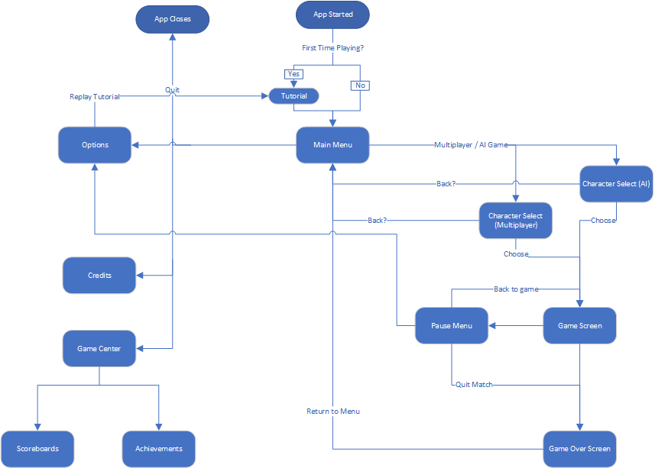

## 6.4 Wireframes

6.4.1 Main Menu

* Game title text.
* Play (Multiplayer) button - will move player to Character Selection screen and enter queue versus other players.
* Play (AI) button - will move player to Character Selection screen and enter queue versus AI.
* Option button - will move player to Options Menu screen
* Quit button - will exit the game.
* Credits button - will move player to Credits screen.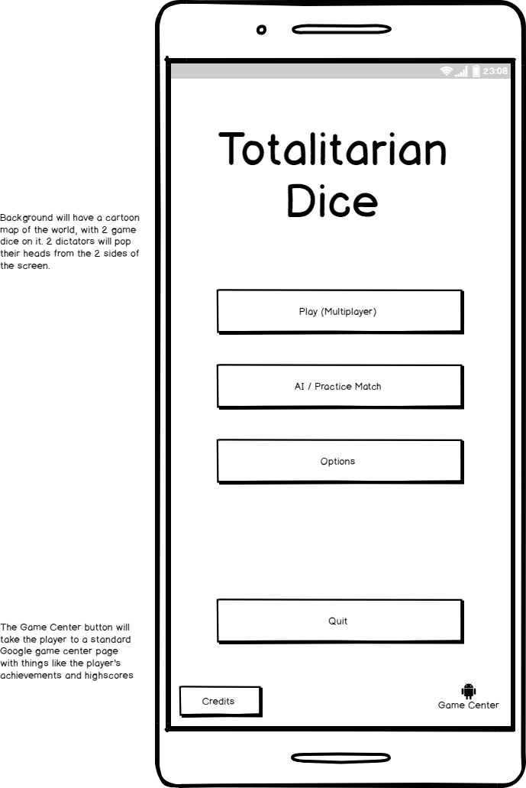

6.4.2 Character Select (Multiplayer)

* Scroll up and scroll down - there will be a slider on the left side of the dictator names.
* Dictator name buttons - the player will select the dictator they want to use for the match.
* Flag - the flag that represents the dictators country.
* Dictator image - will be a caricature of the dictator selected (See section 5.1 Graphic Assets)
* Choose button - will confirm the selection of the character and move the player to queue screen (with a cancel button to cancel queue and return to main menu).
* Back button - go back to main menu.

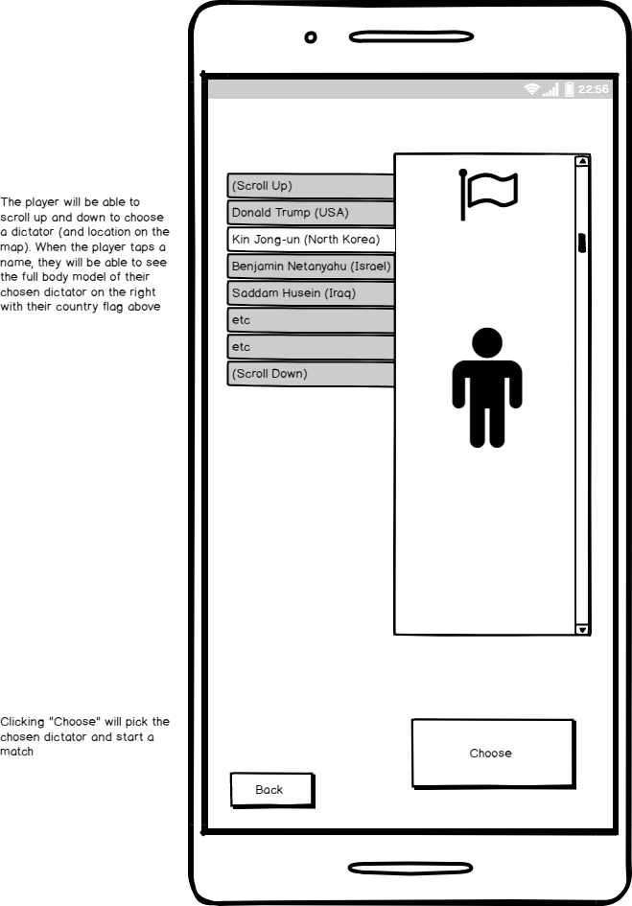

6.4.3 Character Select (Player vs AI)

* Same as Character Select (Multiplayer).
* AI Difficulty - will set the difficulty of the AI characters.

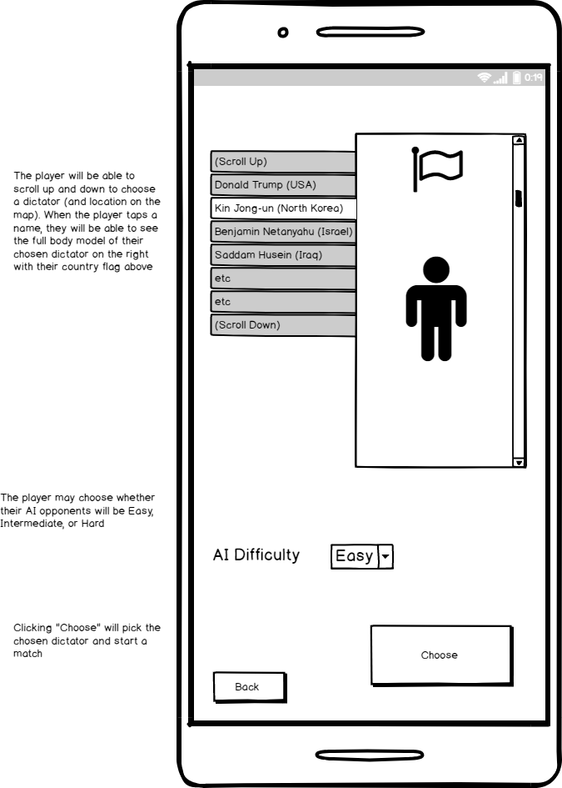

6.4.4 In-game

* Turn Number - a text that will present the number of the current turn.
* Pause button - will move player to Pause Menu.
* Character images on each side - will be with the images of the Dictators the players selected (see section 5.1 Graphic Assets).
* Dice - will show the current dice and which dice are selected.
* Reroll button - will show during the Active Phase of the turn, player can tap on it to reroll the dice.

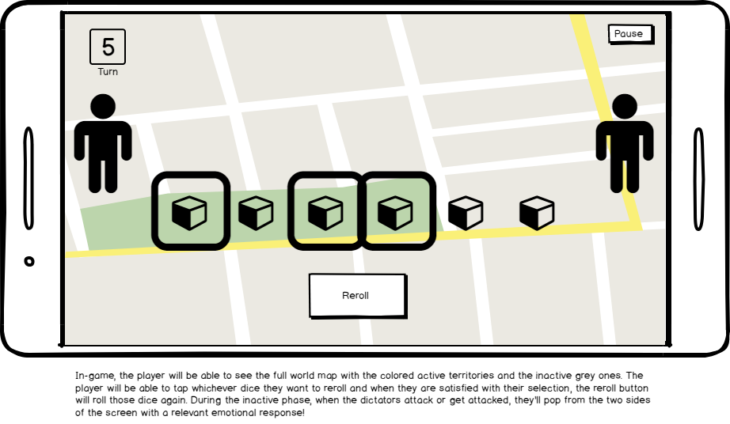

6.4.5 Pause Menu

* Paused - text to show the player the game is paused.
* Options button - will move player to Options Menu screen.
* Return to game button - will resume the game.

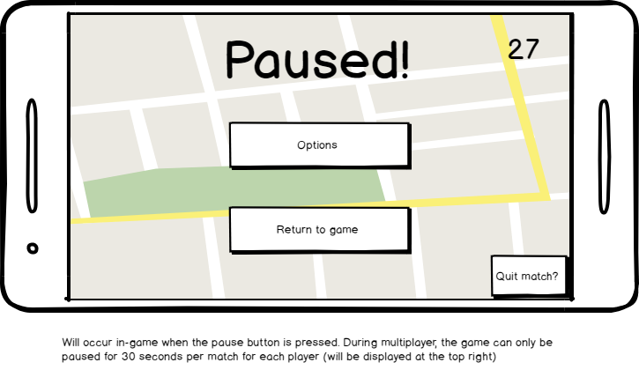

6.4.6 Game Over Screen

* You Won/Finished text - will show the player their place in the match, first place meaning they won the match and other places according to when they lost control over their territories.
* Score text - will show the player their score reward from the current match.
* Back to menu button - will move player to Main Menu screen.

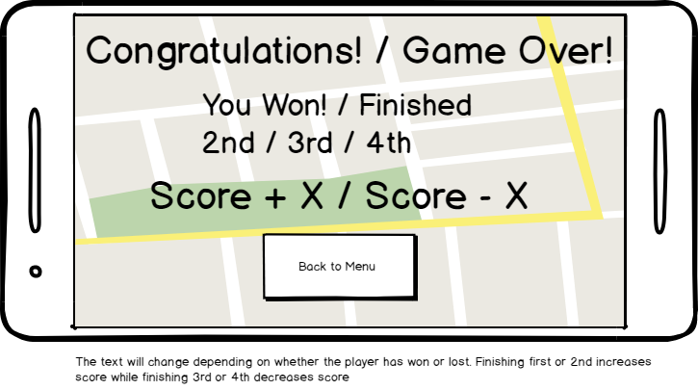

6.4.7 Options Menu

* Options text - to show the player they're in the Options screen.
* Popping Dictators button - toggle show/hide dictator image in the in-game UI.
* Sound - toggle sound effects on/off.
* Music - toggle music on/off.
* Instant Dice Roll - toggle dice animation on/off.
* Battle Animation - toggle battle animations on/off.
* Graphic Quality - set game quality.
* Replay tutorial - will start the tutorial again.
* Back to Menu/Game - will move back to Main Menu or Game screen according to the screen the Options Menu was entered from.

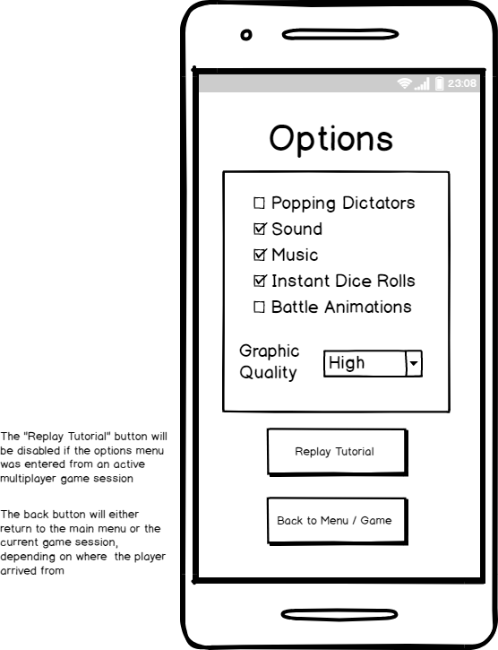

6.4.8 Credits

* Credits title - to indicate the player is in Credits screen.
* Credits text - will show the credits.
* Back button - will move player back to Main Menu screen.

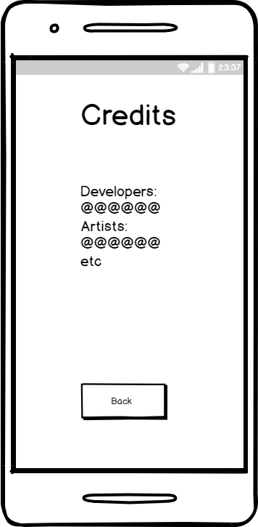

1. How matchmaking is decided will be discussed later in Mechanics
2. Highlighted countries will be discussed later in World Map
3. Actions will be discussed later in Mechanics
4. Will be discussed in Matchmaking
5. See 3.5 Victory Points
6. Victory Points will be discussed later in 3.5 Victory Points
7. Health Points will be discussed later in Mechanics
8. Full health equals 3 health. See 3.3 Capturing Territories
9. A shield has 1 health, the same as normal country Health Points
10. See UI section for highlighted countries explanation